Hearth's Hollow — Town Redesign Plan
Nov 2, 2026 · @Ryan

Direction
Hearth's Hollow should read as the place your light comes home to: a dim village that visibly brightens, grows and fills with people as you cook, clear chapters and gather your party. Everything in it should answer one of the game's four pillars.
Pillar | What it means for the town
Light | The Hearth fire is the town's heart; every chapter cleared lights more lanterns, opens more streets and pushes the dark back. Each building has its own light colour.
Cooking is power | The kitchen is the biggest, busiest district. Ingredients, meals and stations are visible in the world, not only in menus.
A growing party | Classes who join you live and train in town; each one adds something you can see (a banner, a practice target, their own corner).
Runs out, loot home | The Route board at the gate starts every run; what you bring back shows up in the larder, the smithy's racks and the trophy wall.
The rule for every building: what you have earned should be visible from the street. A level-5 station, a full pantry or a top-tier weapon should look different from a new one before you open a single window.
The town stays the hub (station windows over the world, runs start at the Route board), and the camp screen stays as the testing fallback.

Style guide
The biggest style problem today is a mix of three looks: Cainos tiles and props (detailed, larger pixels), Ninja Adventure characters (16 px chibi) and plain coloured shapes for anything neither pack has (anvil, workbench, dummies, stations). The redesign should pick one pixel scale and one source for buildings.
Recommendation: move the town's buildings, props and ground to the Ninja Adventure pack's own tilesets, so people and places share one scale and palette. Keep Cainos only for the dungeons. Check first that the pack's tilesets cover houses, roofs, fences, market stalls and interiors; anything missing is drawn in the same 16 px style.
- Pixel scale: 16 px tiles, characters about one tile tall (as they are now after the 20% cut).
- Palette: warm, low-saturation base (wood, stone, thatch) so the light colours carry the mood.
- Light colour per district:
  - Hearth plaza: gold
  - Kitchen: amber
  - Smithy: deep orange
  - Workshop: warm yellow
  - Training yard: cool white
  - Market street: lantern pink and gold
  - Route board: blue moonlight
- Light by progress: a new town is mostly dark at dusk; each chapter cleared adds lanterns, lit windows and a bigger Hearth glow.
- Time and weather: keep calm day, rain (storms) and night (harvest moon); buildings show lit windows and chimney smoke at night.
- Shapes vs art: no plain-shape props in the final town. Today's shapes (anvil, bench, dummies, stations) are placeholders to replace with sprites.
- Motion: every working building has one looping effect (smoke, sparks, steam, sawdust, flickering light) and one person working.

Town layout
The town keeps today's footprint but groups everything into districts around the Hearth, so each walk has a purpose: wake at home, cook, gear up, leave from the gate.
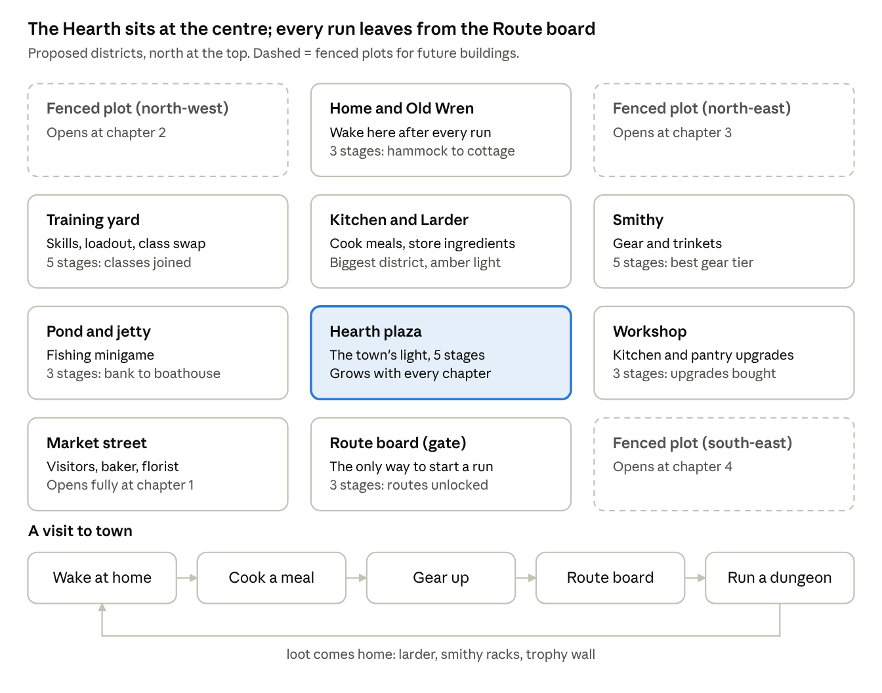
district map · 12 areas, the run loop through town
Most spots stay roughly where they are today; the main moves are the kitchen and larder becoming one district north of the Hearth, and the Route board taking over the south gate.

Core buildings
Ten core buildings, 49 visible stages in total, each stage driven by progress the game already tracks, so no new grind is needed to see the town grow.
Building | What it does | Upgrades with | Stages | What changes stage to stage
The Hearth | Story fire, town light level | Chapters cleared | 5 | Ember, campfire, stone fire-ring, brazier, great beacon; town light radius grows each time
Kitchen (Pot, BBQ, Sandwich) | Cook meals | Each station's level (already 1 to 5) | 5 per station (15) | Campfire, stone ring, hearth, clay hood and chimney, iron ember-forge (already built as shapes)
Kitchen shelter | The kitchen's building | Total station levels | 3 | Open-air, canvas awning, timber kitchen with tiled roof
Larder | Ingredients and meal pantry | Pantry tier (already 1 to 4) | 4 | Crates, shelf racks, root-cellar door, cold room with ice blocks
Smithy | Gear and trinkets | Highest gear tier owned (1 to 5) | 5 | Field anvil, stone forge, bellows, twin forge, master forge with a display rack of your best gear
Workshop | Kitchen and pantry upgrades | Kitchen upgrades bought | 3 | Sawhorse, workbench shed, carpenter's hall with a crane
Training yard | Skills, loadout, class swap | Classes joined (1 to 5) | 5 | One dummy, archery target, sparring ring, a banner per class, a covered dojo
Route board (gate) | Choose a route, start a run | Routes unlocked | 3 | Notice post, map board, lit gatehouse with the map painted on the wall
Home | Where you wake after a run | Chapters cleared | 3 | Hammock, lean-to, cottage with a window that lights at night
Fishing jetty | Fishing minigame | Fish caught | 3 | Riverbank, wooden jetty, boathouse
Rules for every building:
- One window. Using it opens its own station window over the town (as built on 1 Nov); no tabs.
- One worker at work in front of it, with a few spoken lines.
- One looping effect and its own light colour (Style guide).
- Stages never go backwards, and each stage change gets a short moment: dust puff, flash and a toast.

The Hearth and town growth
The town grows in five chapter stages, all driven by story chapters cleared. Each chapter brings the town one step out of the dark, so story progress is the thing you feel most when you walk home.
Chapters cleared | Hearth | The town around it
0 | Cold ember | Most of the town dark, a few lanterns, fenced plots overgrown, few townsfolk
1 | Campfire | Flowers, the market street opens, the baker and florist arrive
2 | Stone fire-ring | Lanterns along every lane, the first fenced plot opens for building
3 | Brazier | Bunting, lit windows at night, the second plot opens, more townsfolk wander
4+ | Great beacon | Light reaches the town edge, the last plot opens, a festival look (banners, music)
- Today: flowers (1+), lanterns (2+) and bunting (3+) are already in; the Hearth's look, plots opening and townsfolk numbers are new.
- Light radius: the Hearth's light gets bigger at each stage, so the dark edge of town visibly moves outward.
- Celebration: the first walk home after a chapter clear plays a short moment at the Hearth (flare, embers, Old Wren says a line).

People, critters and life
The town needs about 22 people and 4 kinds of critter to feel lived in; 14 people and the critters exist today.
Who | Where | Status | What they do
Old Wren | Her cottage by the Hearth | Exists | Story guide, tutorial, chapter hints
Head cook | Kitchen | Exists (1 Nov) | Stirs the pot, cooking tips
Smith | Smithy | Exists (1 Nov) | Hammers at the anvil, gear lines
Carpenter | Workshop | Exists (1 Nov) | Carves at the bench, upgrade lines
Sword-master | Training yard | Exists (1 Nov) | Spars with a dummy, combat tips
Your other classes | Training yard | Exists | Talk to swap class; each gets their own corner (Core buildings)
Merchant, Armourer | Market stalls | Exist (event days) | Sell wares on their event day
Forager | Basket by the market | Exists (event days) | Leaves free ingredients
Baker, Florist | Market carts | Exist | Flavour lines
Larder keeper | Larder | New | Sorts ingredients, says what you're low on
Fisher | Jetty | New | Fishing tips, the day's catch
Gatekeeper | Route board | New | Reads out route hazards before you set out
Children (2) | Plaza | New | Chase the critters, play near the Hearth
Keeper per new building | Fenced plots | New | One for each future building
Critters (slimes, boars, bees, frogs) stay, fly when hit, and grow in number with chapters.
Ambient life to add:
- Lit windows at night.
- Chimney smoke above working buildings.
- Birds that scatter when you dash past.
- Fireflies at night.
- Wind moving the bunting.
- Footstep dust on dirt paths.

Future buildings
The three fenced plots (north-west, north-east, south-east) open one per chapter from chapter 2, and each can take one of these buildings. The Lamp-maker, Smoker and Shrine fit best first, because they deepen light, cooking and runs.
Building | Pillar | What it adds | Stages | Unlock idea
Lamp-maker | Light | Upgrade your carried light, Flare and torches (radius, cooldown, colour) | 4 | Chapter 2 plot, Lantern Bee materials
Smoker | Cooking | A 4th station: smoked dishes whose buffs last two runs | 5 | Chapter 2 plot, after Pot level 3
Shrine of the Hearth | Runs | Choose 1 of 3 blessings to carry into the next run (the in-run blessings idea) | 3 | Chapter 3 plot, first boss trophy
Bakery and Oven | Cooking | A 5th station: pastries with speed and gather buffs | 5 | Chapter 3 plot, after Sandwich level 3
Herb garden | Cooking | Grows a few ingredients between runs | 4 | Any plot, seeds from foraging
Apiary | Cooking | Fire honey and wax on a timer | 3 | Any plot, after Wild Hive
Trophy hall | Runs | Boss trophies on display, each a small permanent bonus | 3 | Chapter 4 plot, 3 bosses beaten
Map-maker | Runs | Scouts routes: shows mutators and hazards before you set out | 3 | Any plot, 10 routes cleared
Tavern | Party | Visitors, side quests, a notice of bounties | 4 | Late game, all classes joined
Critter pen | Life | Adopt a town critter as a companion that follows you | 2 | Any plot, critters bopped 50 times
Plots could later grow into a fourth and fifth, for example by extending the town past the gate, so the list is longer than the three plots on purpose.

Asset and build checklist
The full redesign is about 85 building looks, 40 props, 8 new characters, 12 effects and 7 new code systems. The core town is about half of that, and the future buildings can come one at a time.
Art
Item | Count | Source | Notes
Town tileset (grass, paths, plaza stone, fences, walls, water) | 1 set | Ninja Adventure pack | Replaces the Cainos town tiles
Core building stages | 49 | Pack tiles + drawn to match | Hearth 5, Kitchen stations 15, Kitchen shelter 3, Larder 4, Smithy 5, Workshop 3, Training yard 5, Route board 3, Home 3, Jetty 3
Future building stages | 36 | Drawn to match | 10 buildings, 2 to 5 stages each
Props | about 40 | Pack + drawn | Anvil, bench, dummies, racks, barrels, sacks, jars, signs; replaces today's plain shapes
New townsfolk | 8 | Ninja Adventure characters | Larder keeper, fisher, gatekeeper, 2 children, 3 plot keepers
Looping effects | 12 | Code (existing FX) | Smoke, sparks, steam, sawdust, fireflies, birds, lit windows, bunting wind, 5 Hearth fire sizes counted as one
District light colours | 7 | Code | One per district (Style guide)
Station window headers | 20 | UI | One per core and future building
Code systems
- ☐ Building stage system: data per building (stages, what drives them, sprite per stage) and a rebuild when a stage changes
- ☐ Stage-up moment: dust, flash, toast, saved so it plays once
- ☐ Town growth: Hearth stage, light radius, plot unlocks and townsfolk count from chapters cleared
- ☐ Plot system: choose which future building goes on an opened plot
- ☐ New station windows for each future building
- ☐ Layout rework into districts (Town layout)
- ☐ Ambient life additions: birds, fireflies, lit windows, footstep dust

Order of work and open decisions
Build the system before the art: once buildings can change stage from data, every new look is just a sprite and a row.
- Style test: rebuild one district (the kitchen) with Ninja Adventure tiles to confirm the look before redoing the rest.
- Building stage system, wired to the drivers the game already has (station levels, pantry tier, gear tier, classes joined, chapters).
- Layout rework into districts, keeping every current spot working.
- Core buildings, one district at a time: Kitchen and Larder, then Smithy and Workshop, Training yard, Route board and Home, Jetty.
- Hearth and town growth by chapter, including the celebration moment.
- People and ambient life (new townsfolk, birds, fireflies, lit windows).
- Future buildings, starting with the Lamp-maker, Smoker and Shrine.
Decisions for Ryan:
- ☐ Switch the town to Ninja Adventure tiles, or keep Cainos and draw buildings to match it?
- ☐ Are the stage counts per building right (Core buildings table)?
- ☐ Plots: fixed buildings per plot, or does the player choose what to build?
- ☐ Which three future buildings come first?
- ☐ Should building stages cost anything extra, or only follow progress you already make?
- ☐ Is a festival at chapter 4+ wanted, and is music in scope?

